Sum

**Poringland Primary School and Nursery**



**Behaviour Policy**

**Date of Policy: Spring 2024**

**Review Date: Spring 2027**

**Members of staff responsible: Senior Leadership Team**



**Happy Active Inspired** **Healthy Learners**

**Respectful, Kind and Honest**

**Behaviour for Learning Policy**

**Name of school:** Poringland Primary School and Nursery

**Date of Policy:** Spring 2024

**Date of Review:** Spring 2027

**Members of staff Responsible:** Senior Leadership Team

1. **Introduction**
   1. AtPoringland Primary School and Nursery we believe in the concept of lifelong learning, and in the idea that both adults and children learn new things every day. We maintain that learning should be a rewarding and enjoyable experience for everyone; in short, it should be fun. Through our teaching, we equip children with the skills, knowledge and understanding necessary to be able to make informed choices about the important things in their lives. We believe that appropriate teaching and learning experiences help children to lead happy and rewarding lives.
   2. All children will leave Poringland with a desire to learn, inspired by innovative teaching and active learning; with the skills and self belief to enable them to succeed; with the confidence to solve problems, welcome challenges and to be independent learners who have a love for learning. Children will understand the importance of a healthy, active lifestyle. They will have a respect for others and a sense of moral responsibility as citizens in a modern world.
   3. Poringland Primary School and Nursery will be known for its caring, supportive environment; a school where staff are valued and respected, who work together tirelessly to ensure everyone reaches their potential, both children and adults.
   4. The vision for our school means that we want:

**Happy**

**Active**

**Inspired**

**Healthy**

**Learners**

* 1. The values for our school means that we expect **everyone** to behave in a way that is:

**Respectful**

**Kind &**

**Honest**

1. **Rationale**

The purpose of this policy is to provide an effective framework for promoting achievement and improving positive behaviour.

It will:

* Ensure a calm, orderly and supportive school environment where positive learning can take place.
* Protect pupils from endangering themselves, others or property.
* Protect pupils from any form of physical intervention which is unnecessary, unlawful, excessive or inappropriate.
* Encourage pupils to take control of their own behaviour from a therapeutic approach
* Assist staff in managing challenging behaviours while maintaining a positive school ethos.
* Minimise the risk of accusations of improper conduct.

1. **Principles**

Aims:

* To achieve consistency through a whole school approach.
* A shared understanding of positive handling and the structure which supports it.
* Promote confidence and reduce stress in staff and pupils.
* Improve delivery of the curriculum and raise standards.
* Instil trust between staff and pupils.
* Recognise that on pursuit of an inclusive school community there will be children who require a personalised approach to their specific behaviour needs.
  1. Rights of pupils

We believe that pupils atPoringland Primary School and Nursery are entitled to:

* Feel safe and secure.
* Experience a rich and varied curriculum.
* Experience a supportive environment where effort and achievement is encouraged.
* A differentiated approach which caters for physical, emotional, social and spiritual need.
* Have their rights and responsibilities recognised and nurtured.
* Feel valued.
* Recognise and gain control of their own behaviour.
* To have a voice and opinion.
  1. Acceptable standards of behaviour

Pupils at Poringland and Primary School and Nursery are encouraged to:

* Respect the rights of others.
* Show courtesy and care.
* Accept responsibility for their actions.
* Be involved in choices and decision making regarding their behaviour.
* Recognise the rights of others to learn.
* Extend their skills and knowledge to wider situations.
* Respect the environment/property in the school and the wider community
* Reflect, repair and restore following any experiences of high anxiety
* Pupils develop their own code of conduct or ‘rules’ with staff when appropriate
  1. Staff responsibilities:

All staff will:

* Treat pupils with respect.
* Actively seek support for their own training needs and understanding of pupil need.
* Maintain an environment which is conducive to learning.
* Celebrate success and ensure all pupils experience it.
* Accept pupils as individuals.
* Be consistent, firm and fair.
* Establish positive relationships. We understand that children are influenced by their surroundings therefore all adults will model positive behaviour and positive interactions.
* Demonstrate a duty of care.
* Support their colleagues by being a critical friend and offer support where plausible.
* Have a therapeutic approach to meeting the emotional needs of pupils.
  1. Parents responsibilities:

Parents will:

* Support the school approaches to help pupils make more positive choices.
* Receive and read information regarding their son or daughter’s behaviour.
* Receive and read SEN Support and Inclusion plans.
* Use the complaints procedure to register concerns.
* Communicate with the school regarding any issues that may impact on their child’s emotional wellbeing.

1. **Procedures**
   1. Staff training

The school uses the ‘Norfolk Steps’ programme. It is based on Therapeutic Approaches and its philosophy and method involves the use of de-escalation, consistency, good communication and planning in order to reduce the incident of restrictive physical interventions.

Norfolk Steps (Step On and Step Up) is an integral part of supporting the complex needs of some of our pupils. It is a requirement of the job that all class based staff (and some support staff) will receive this training from qualified trainers along with comprehensive updates and access to continued support. Unless assessed to be a credible witness, it is expected that all staff will support across the school as and when required. Failure to do so may result in disciplinary action being taken if all options of support have been explored and exhausted. There are instructors within the staff team. All staff are expected to positively engage with the training requirements to ensure they hold suitable knowledge to work across the school and across the range of needs. All starters receive “Step On” training and some members of staff are trained in “Step Up” to support our pupils who have more complex needs. Everyone receives training every 2 years for “Step On” and annually for “Step Up”, where appropriate. We see this as essential because it is the responsibility of all staff to keep pupils and colleagues safe

Some staff will receive “Step Up” training which includes training in the safe use of commonly used physical interventions and restrictive physical interventions which is refreshed annually. This training will be carried out by the in-house STEPs trained instructors. They will be able to train 12 delegates at a time, to ensure the correct procedures are adhered to.

It is expected that staff will demonstrate language and attitude in line with school ethos, this policy and Norfolk Steps training. It is expected that staff will work collaboratively with the Leadership team to address any arising issues. All staff must follow the advice and support given from other agencies including Starfish and Starfish plus (<https://www.norfolkcommunityhealthandcare.nhs.uk/starfish-ld-camhs-and-starfish/>)

In between refreshers, staff have access to tutors for further advice and training. This may include the training in more specific restrictive physical interventions to support pupils as individual need arises in class teams or opportunities to refresh our practise in school briefing sessions.

All staff who have received training are authorised to have care and supervision of pupils which may include the need to intervene physically in line with school policy and Norfolk Steps training. Other staff, including new staff awaiting training, are briefed by instructors in effective assistance. This applies within and off premises.

Norfolk Steps Instructors have access to mentoring from the Norfolk Steps team and attend yearly updates/refreshers.

* 1. Rewards

We recognise that pupils achieve more by positive interventions. All strategies and interventions will include rewards, often as simple as praise.

Praise can be given formally or informally, in public or private, to groups or individuals.

Classes have their own reward structures. School assemblies recognises achievements publicly, through the presentation of Vision and Value awards. Where this may not be seen as a positive experience by the pupil, our praise will be communicated to them in an appropriate and personalised way to them.

* 1. Consequences

Consequences should be derived through logic and should be something that naturally or logically follows on from the action.

Educational Consequences

Should allow the learning, rehearsing or teaching of a skill so that the freedom can be returned. Examples of this could be: completing a task, rehearsing, assisting with repairs, educational opportunities, research or restorative meeting if appropriate to the pupil. Protective Consequences Removal of freedom to manage the level of harm. This could include increased staffing levels, limited access to outside space, escorted in social situations, no availability of minibus/car, differentiated teaching space and exclusion.

If for a variety of reasons, we are unable to meet the needs of a child within our school, using all of the strategies suggested within this policy we would do the following:

We would move towards part-time timetables; temporary exclusions and where it is deemed necessary a permanent exclusion. At the point of permanent exclusion, we will need to refer to our exclusions policy - where behaviours stated below will warrant a permanent exclusion:

* Any incident which poses a risk to other pupils or members of staff, e.g. bringing a weapon onto the premises
* Any incidents which breach the law
* Persistent and severe bullying
* Verbal and physical abuse
* Constant disruption
* A single, serious and major incident, e.g. serious assault on another individual leading to injury
  1. Inclusion Plans

These will be drawn up if a pupil’s behaviour is challenging or is likely to cause harm. It targets specific behaviours and outlines the strategies in place to move them toward more prosocial behaviours. The focus of any strategy and related intervention should always be to deescalate. All staff have access to this information on Edukey and in class folders and the inclusion plan is to be shared with parents by the class teacher. Staff are required to familiarise themselves and follow these plans for pupils they regularly work with. Inclusion Plans are reviewed regularly by the class teacher/1:1 TA, at least once every 3 months. They are authorised by the Inclusion Team (Peter Dean, Hannah Howard, Emma Steward).

***Procedures are in appendix one and four***

1. **Physical Intervention**
   1. Supporting guiding and Escorting

We acknowledge that there are occasions when staff will have cause to have physical contact with individuals for a variety of reasons, for example: to comfort a child in distress (so long as this is appropriate to their age and understanding), to direct a person or for activity reasons (for example in drama, physical games), for the safety of others or when accessing the community. This applies to all pupils in our school and does not require an Inclusion Plan or need recording on a behaviour form. Staff to consult EYFS (Early Years Foundation Stage) Policy, Lone Working Policy and Safeguarding policy. We want to ensure pupils are well prepared for life beyond us. With this is mind, alongside the knowledge of susceptibility of injury, hypermobility and risk to both parties, all staff are actively encouraged to offer pupils an arm rather than hand holding.

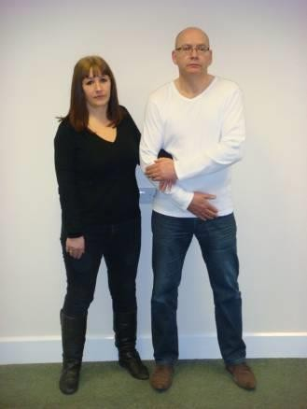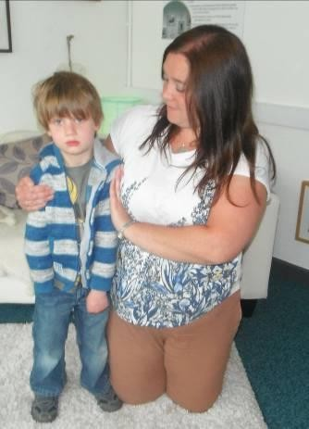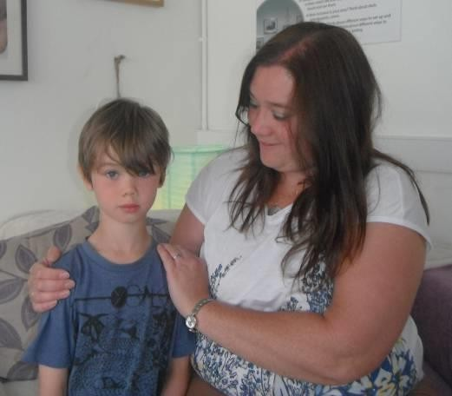

Shoulder Hug Arm Hug Offering an arm

* 1. Restrictive Physical Interventions

Restrictive physical intervention involves the use of overpowering force to control a person’s behaviour. It can be used when:

* The pupil is at risk of harm.
* Others may get hurt or have been hurt.
* There is a risk of severe damage to property.
* Where good order and discipline is threatened or when there is a loss of education for the pupil themselves or others.
* A criminal offence is about to be committed.

It is used:

* When other actions have not improved the situation or there is deterioration.
* Where any other course of action is likely to fail.
* Where immediate action is necessary.
* When early physical intervention will prevent a dangerous or disruptive situation. Staff make a balanced judgement about use from their experience and expertise, taking account risks to themselves, others and property.

It is never used:

* To punish.
* To cause or threaten harm.
* To oppress, intimidate or bully.

Planned physical interventions and restrictive physical interventions are part of the Inclusion plan for the pupil. Where they are not- there use should be reviewed and the Class teacher/1:1 TA will amend the plan as necessary if felt it may need to be used again on more than one occasion.

The techniques used in physical interventions and restrictive physical interventions are as a result of ongoing risk assessment in an effort to safeguard everyone in an incident where physical intervention/restrictive physical intervention is necessary. Whilst some physical injury or pain potential can be reduced there always remains some risk (risk assessments are part of the inclusion plan for a pupil).

There are elevated risks related to some techniques used in physical interventions/restrictive physical interventions, these will have been highlighted in all Norfolk Steps training and refresher courses.

Unplanned interventions occur where a pupil behaves in an unexpected way.

Seclusion **-** prevents a person from leaving a room or building of his own free will may be deemed a restriction of liberty and is only permissible in very specific circumstances in conjunction with a court order.

Withdrawal - involves removing the pupil from a situation which causes distress or anxiety to the pupil or others to a location where they can be continuously observed and supported until they are ready to resume their activities**.**

The Bungalow is used to support planned withdrawal. Where the Bungalow is used to support a pupil to de-escalate this must be monitored at all times. The use of the Bungalow will be a planned response and will be written into the pupils Inclusion Plan. Where the Bungalow is used to support a pupil to de-escalate in an unplanned situation this will be reviewed by the class teacher and Norfolk Steps Instructors - amendment to the Inclusion Plan will be made where necessary. Other areas used in the school for withdrawal may include The SLT offices, The Boardroom, shared areas such as the library, playgrounds and the courtyard. The area used will be specific to the pupil and be planned with knowledge of their de- escalation and in consideration of theirs and others safety. Once a child has de-escalated they will return to normal routines - if this is deemed appropriate.

Where a pupil is using any of the outside areas for withdrawal then a member of staff must be outside with them at a distance safe to all. The pupil must be able to regain access to the building i.e. the door being open where it is deemed safe for the pupil to be monitored closely from the classroom. The class team have a duty to inform others who may wish to use the area if it is safe to do so.

**All restrictive physical intervention should involve the minimum physical force necessary. The restrictive physical intervention should be as short as possible.**

**The force used must be seen as reasonable, necessary and in proportion to the consequences it is intended to prevent.**

* 1. **Recording**

It is important that detailed recording is provided, both to inform future planning and protect staff and pupils.

All incidents meeting the criteria below should be recorded within 24 hours after an incident using CPOMs. The incident should be recorded by those involved with any physical element in the first instance but where there was no physical contact it will still need recording on CPOMs. Clear staff communication is key to ensure clarity of who is recording the incident.

Incidents to report:

* Where there has been any Restrictive Physical Intervention, Physical Intervention for Personal Safety
* Injury
* Attempt to injure
* Damage to property
* Disruption to the learning of others
* Intense de-escalation to keep the pupil emotional
  1. Monitoring, Evaluation and Feedback

This is done by the Norfolk Steps instructors/Headteacher using CPOMs, inclusion plans and class monitoring. It is a shared ethos that feedback is given personally or as a whole class/staff to ensure that practise is in line with policy and training. It is part of our commitment to continually reflect and progress both the expectations of a pupil and our knowledge and rationale.

The head teacher reports to Governors

# To be read in conjunction with:

Mission Statement

Staff code of conduct Policy

DCSF (Department for Children, Schools and Families) /DoH Guidance on the use of restrictive physical interventions for staff working with children and adults who display extreme behaviour in association with learning disability and/or autistic spectrum disorder; July 2002 found on the server in “Support and Intervention Aids” (<https://assets.publishing.service.gov.uk/media/5a819959ed915d74e6233224/Use_of_reasonable_force_advice_Reviewed_July_2015.pdf> )

<https://assets.publishing.service.gov.uk/media/5d1387e240f0b6350e1ab567/reducing-the-need-for-restraint-and-restrictive-intervention.pdf>

EYFS Policy

Touch Policy (attached to this policy)

Lone Working Policy

Safeguarding Policy

Keeping Children Safe in Education; 2023

**APPENDIX 1: Procedures for Behaviour Management**

# Planning

* If a pupil is causing concern this needs to be raised at a class team meeting.
* The team can decide to gather more information by observation sheets (See Appendix 5 – Behaviour and Feelings tracker and/or Appendix 6 – Roots and Fruits)
* Norfolk Steps tutors are available to assist with observations.
* Norfolk Steps instructors will assist teams to draw up the plans.
* Where there is sufficient concern a S+I plan should be written
* The plan is the responsibility of the class teacher.
* It is reviewed at least every 3 months.
* If a pupil’s movement is restricted this must be planned for.

Wherever possible the pupil should be involved in this process.

A copy will be saved on EduKey and approval requested by the class lead to a Norfolk Steps Tutor overseen by Hannah Howard and Emma Steward.

Once approved, the class team will send a copy home for information with an accompanying letter. It is helpful to call parents beforehand if this is the first plan for that pupil. Class teams may use images from their Norfolk Steps training to help clarify any terminology to parents/carers.

The plan should be shared at a class team/Key-Stage meetings to enable staff to discuss the information. All staff have access to all SEN Support and Intervention Plans on EduKey to enable them to work with pupils across the school.

# Recording

All incidents are recorded onto CPOMs when challenging or dangerous behaviour occurs. This can include:

* Restrictive Physical Interventions, Physical Intervention or Personal Safety Techniques have taken place.
* If there was injury or potential injury to the pupil, other pupils, staff or others.
* If there was significant damage to property.
* Significant disruption to learning.

# Support for Pupils

It is important that pupils are given opportunities to discuss their behaviour. If they are able, they will review and debrief following incident with a key member of staff. At a cognitively appropriate level. This may include the use of drawings, comic strip conversations and verbal discussions. The purpose of this being to assist with positive changes towards more prosocial behaviour in the future.

Other pupils may also need opportunities to talk about their feelings and be given support and praise. Sometimes we will withdraw a pupil from a class for a period of time to give others some respite. Generally other pupils are encouraged to ignore challenging behaviour, but this is not always possible.

Appendix 3 outlines the schools principles around touch, particularly when supporting pupils.

# Support for staff

It is acknowledged that this can be an emotional area for staff in often challenging situations. Class teams have a duty to support each other by debriefing, post incident repair and reflection. This will sometimes involve honest discussion about emotions. Norfolk Steps instructors can offer support. If additional staffing is needed to support with debriefing, post incident repair and reflection, classes can support each other or ring the Office who will contact a member of Leadership where possible.

The Norfolk Steps instructors are able to offer further training for class teams or individuals and will assist with planning.

There is no sense of failure in needing help, it is always seen as a strength that staff can recognise this.

Staff have a right to take reasonable measures to protect themselves from harm, both physically and mentally. The Head Teacher has a duty to protect staff. Staff have a duty to inform the Business Manager or the Head if they have a medical issue which affects their work.

If staff witness anything which concerns them or which they need more information about they must report it to the Norfolk Steps instructors.

# Risk Assessment

The SEN Support and Inclusion plan includes a space for the identification of risks and appropriate steps taken to reduce these.

It is acknowledged that staff can avoid unreasonable risks but if we are to provide learning opportunities there are situations where we will take calculated risks. Some of our pupils would not experience new or enriching situations if we attempted to eliminate the risk of challenging behaviour. Our task as educators is to widen the world of our pupils, not restrict it.

We can reduce risk in several ways, looking at staffing levels, training, the environment and support for the pupil.

# Explaining behaviour expectations to students

We will communicate expectations and explanations regarding behaviour in the way that best helps the student understand the message. This might be through talking or it might be through social stories or symbols or a combination of each.

# Social stories

Social stories (Widgit - <https://widgitonline.com/en/home>) are short descriptions of a particular situation, event or activity, which include specific information about what to expect in that situation and why.

Social stories can be used to:

* Develop self-care skills (eg how to clean teeth, wash hands or get dressed), social skills (eg sharing, asking for help, saying thank you, interrupting) and academic abilities
* Help someone to understand how others might behave or respond in a particular situation
* Help others understand the perspective of an autistic person and why they may respond or behave in a particular way
* Help a person to cope with changes to routine and unexpected or distressing events (eg absence of teacher, moving house, thunderstorms)
* Provide positive feedback to a person about an area of strength or achievement in order to develop self-esteem
* As a behavioural strategy (eg what to do when angry, how to cope with obsessions).

# Symbols

Symbols can enhance understanding and learning by displaying a visual image that can be more easily understood than spoken language and other forms of communication.

**Appendix 2: Pupil code of conduct**

Visible consistencies at Poringland Primary School and Nursery



* Every child has the chance to be a child/pupil of the day, they receive certain privileges such as line leaders, receiving compliments from peers an dgiving out star stickers
* Every classroom has a sticker book (KS1) for public recognition
* Weekly celebration assembly – vision and value awards
* Meet and greet every child in the morning
* Positive phone calls home
* Triangulate praise with other adults
* PATHs used to support emotional development and understanding
* PATHs used as our behaviour curriculum
* Emotional regulation supported by emotion cards/colour monsters (EYFS)
* Whole class recognition treat
* School vision and values poster up in every classroom

Our school values of ***Respectful, Kind and Honest*** underpin our behaviour policy.

**Points**

The behaviours we are looking for: Respectful, Kind and Honest.

We recognise these behaviours in the following ways:

* Star stickers for KS1, house points for KS2
* Catch them being good – look for opportunities to publicly praise/give stickers/house points
* Name the behaviour when issuing sticker/house point
* Stickers to go into housepoint book (KS1) – once completed they are celebrated by SLT and move onto the next book
* Each class has a whole class recognition eg. Marbles in a jar etc

***For steps please see below:***

**Points, Reminders and Steps**

|  |  |  |  |  |  |
| --- | --- | --- | --- | --- | --- |
| **Points** | **Reminder** | **Step 1** | **Step 2** | **Step 3** | |
| - Happy, Active, Inspired, Healthy Learners  - Kind, Honest and Respectful  - ready to learn  - positive contributions | -Not following school vision and values | -Continuing not to follow instructions  - inappropriate language  - disrupting learning | Persisting with the following behaviours:  - not following instructions  - inappropriate language  - disrupting learning | - Harm to peers  - Harm to staff  - Damage to property  - Harm from disruption  - Harm from absconding | |
| **Reward** | **Consequences** | | | | |
| Individual house points (turn into class points)  Class points to earn half termly reward: trip, choice of indoor activity, extra outdoor learning  Class recognition – House points total acknowledged in assembly with ten mins extra play? |  | Time off break time (5 mins) | Time off break time (10 mins)  Move within the classroom | Harm to peers | Miss break time or 15 minutes of lunchtime  Removed from class to buddy class  Repair and reset  Class teacher to phone home  UNLESS harm is severe then out with SLT |
| Harm to adults | Straight to SLT  Phone call home  IEX/FEX |
| Damage to property | Removed from class to buddy class  Repair and reset  UNLESS wilful intent is used in this case sent to SLT  Class teacher to phone home |
| Harm from disruption | Miss break time or 15 minutes of lunchtime  Removed from class to buddy class  Repair and Reset  Class teacher to phone home |
| Harm from absconding | Time out with SLT  Phone call home  Repair and reset |

NB Repair and reset after each teaching session (3 sessions in one day)

**APPENDIX 3: Touch policy**

At our school, we have a touch policy. This means that as a member of staff you are able to physically guide, touch or prompt children in appropriate ways at the appropriate times. It is extremely important that you have read and understood this policy to appreciate the reasons why we may choose to hold/touch children and the appropriate ways to do so.

**Why do we use Touch?**

We may choose to hold children for a variety of reasons, but in general terms we would normally do so for either comfort or reward. We may also need to physically touch, guide or prompt pupils if they require personal care, assistance with writing, eating, dressing etc.

**How do we use Touch?**

**Hugging**

At this school, we encourage staff that are using touch for comfort or reward to use a ‘school hug’. This is a sideways hug, with the adult putting their hands on the child’s shoulders. This discourages ‘front on’ hugging, and the adult’s hands on the shoulders limits the ability of the child to turn themselves into you. This can be done either sitting or standing.

**Hand-Holding**

We recognise that children sometimes enjoy being able to holds hands with adults around them. This is perfectly acceptable when the hand holding is compliant. However, if the handholding is being used by an adult as a method of control to move children, this can become restraint. Therefore, we encourage the use of the ‘School hand-hold’. This is done by the adult holding their arm out, and the child is encouraged to wrap their hand around the adult’s lower arm. The adult’s other hand can be placed over the child’s for a little extra security if it is required.

**Lap-sitting**

At our school we discourage lap-sitting. Children should be taught to seek comfort/attention through other means, for example the school hand hold/hug. If a child attempts to sit on your lap, explain to them that this is not what we do here, and ask them to sit next to you if it is appropriate.

At times, children maybe in such crisis or distress that they hold you in a way which is not described above (e.g. ‘front on’ hug/lap sitting). If this should happen, please ensure that you have recorded this on CPOMS or another member of staff to protect yourself. This will be in order to record and monitor the amount of times the pupil is doing this to staff to see whether this is ‘controlling’ behaviour, or whether the child is displaying distressed behaviour regularly.

Please note that although we have a touch policy and believe contingent touch can be a positive experience for the children that we care for, this does not mean that you have to touch children, and it should also be realised that some children will not want to be touched. Please respect this.

We also have within our behaviour policy, a section on restrictive intervention, please ensure that you are familiar with this.

Staff have a ‘Duty of Care’ towards the pupils in their care. Therefore, if a pupil is likely to be at risk of harm if you do not physically intervene in an emergency situation, you must take action. The action you take will be dependent on the dynamic risk assessment that you at the moment in time.

Parents/carers will be made aware of this policy when their child is admitted to this school.

If you have any questions or would like further discussions regarding this policy, please speak to a member of the senior leadership team at the earliest available opportunity.

**Appendix 4 – Planned Physical interventions STEP ON**

**Hand shapes**

In Step On, two different hand shapes are used.

The hand shapes help to prevent, or minimise, the likelihood of any gripping or grabbing by adults when they use Step On physical intervention techniques.

Any gripping or grabbing could be interpreted as restrictive physical intervention techniques which do not form any part of Step On.



Open hand

Open hand

Closed hand



**Open hand**

The open hand shape is where the fingers remain ‘glued’ together with the thumb away from the fingers.

In Step On, the hand is used with the hand parallel to the floor to help prevent gripping and grabbing.

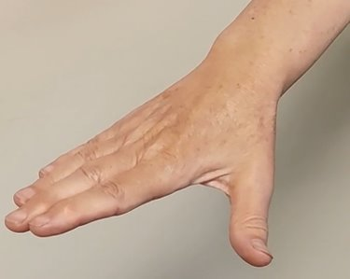

* Flat hand
* Fingers together
* Thumb away from the fingers
* Palm parallel to the floor

**Closed hand**

The closed hand shape is where the fingers and thumb remain ‘glued’ together.

In Step On the closed hand shape may be a flat hand or a ‘curved’ hand.

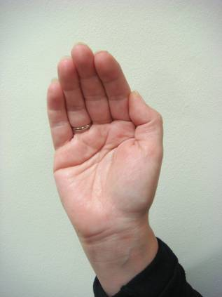

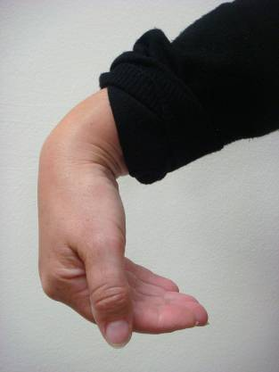

* Flat hand
* Fingers and thumb together

**Shoulder hug / guided shoulder hug (closed hand)**

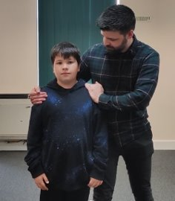

The shoulder hug can be used in a range of situations such as, for comfort, reward, distraction.

You can walk with a child or young person. This is called a **‘guided shoulder hug’.**

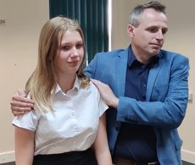

* Sideways stance
* Closed hand on each shoulder
* Communicate intention
* Use a ‘de-escalation script’ if needed

**Arm hug (closed hand)**

The arm hug is used when the child or young person’s arm needs to be kept close to the side of their body to help lessen arm movement.

You can walk with the child or young person, this is known as the **‘guided arm hug’**

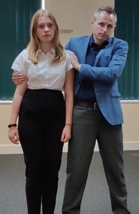

* Sideways stance
* Positioned behind the elbow
* Closed hands used above the elbows to maintain safe shape
* Communicate intention

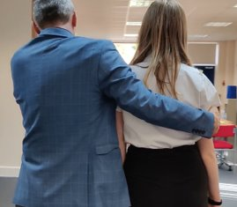

**Guided arm hug (closed hand)**

The arm hug is used when the child or young person’s arms need to be kept close to the side of their body to help reduce arm movement.

You can walk with the child or young person, this is known as the **‘guided arm hug’**

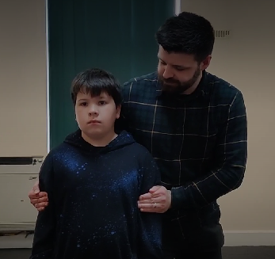

* Sideways stance
* Positioned behind the elbow
* Closed hands used above the elbows to maintain safe shape
* Communicate intention

**Paired guided arm hug**

**(closed hand)**

Sideways stance

Closed hand on shoulder and arm (above the elbow)

Walk briskly to minimise kicking and dropping to the floor

Communicate intent

Use scripts

Know your destination

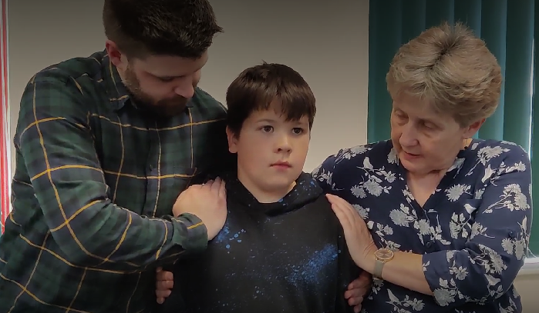

]



Guided arm hug (open hand)

Stabilise and turn (open hand)

Guided shoulder hug (closed hand)

Guided arm hug (closed hand)

Arm hug (closed hand)

Shoulder hug (closed hand)

Guided alternative to hand hold (closed hand)

Guided hand hold

Responsive de-escalation

Positive prosocial use of touch

Proactive de-escalation strategies

Targeted physical intervention techniques

Everyday physical intervention techniques

**Continuum of physical intervention**

Paired guided arm hug (open hand)

Guided arm hug (open hand)

Targeted physical intervention techniques

Responsive de-escalation

Paired guided arm hug (open hand)

Paired guided arm hug (closed hand)

**Appendix 5 – Behaviour/feelings tracker (copy of this is on the shared drive)**

**Tracker**

*(can be used to track uncomfortable feelings or behaviours)*

|  |  |  |  |  |  |  |  |  |  |  |
| --- | --- | --- | --- | --- | --- | --- | --- | --- | --- | --- |
|  |  |  |  |  |  |  |  |  |  |  |
|  |  |  |  |  |  |  |  |  |  |  |
|  |  |  |  |  |  |  |  |  |  |  |
|  |  |  |  |  |  |  |  |  |  |  |
|  |  |  |  |  |  |  |  |  |  |  |
|  |  |  |  |  |  |  |  |  |  |  |
|  |  |  |  |  |  |  |  |  |  |  |
|  |  |  |  |  |  |  |  |  |  |  |
|  |  |  |  |  |  |  |  |  |  |  |
| **Session** | **Session** | **Session** | **Session** | **Session** | **Session** | **Session** | **Session** | **Session** | **Session** | **Session** |

**Name: Tracked by: Date / Time frame:**

**Appendix 6 – Fruits and roots (copy of this is on the shared drive)**

**Roots & Fruits Analysis**

|  |  |
| --- | --- |
| Name: |  |
| Date of analysis: |  |
| Date of review: |  |
| [https://media.istockphoto.com/vectors/green-summer-tree-with-roots-vector-illustration-plant-in-garden-vector-id981594652?k=6&m=981594652&s=612x612&w=0&h=pzf8mM--1wso6gCX0l8J16iQq2iijNf0w2hpVF9ZCqw=](https://www.google.com/url?sa=i&rct=j&q=&esrc=s&source=imgres&cd=&cad=rja&uact=8&ved=2ahUKEwjHr-abjvHmAhUADWMBHYSIB8kQjRx6BAgBEAQ&url=https://www.istockphoto.com/illustrations/tree-roots&psig=AOvVaw04vFFJTX1VDtZSgIuyd9tL&ust=1578473516703386)Who contributed to this analysis? |  |

Positive behaviour

Behaviours that challenge or harm

Positive experiences

Uncomfortable feelings

Comfortable feelings

Negative experiences

**Appendix 7 – Exemplar scripts to use for inclusion plans etc (copy of this is on the shared drive)**

**Behaviour scripts (use alongside emotion cards)**

I can see there’s a problem, can you tell me what happened?

How do you feel? (If child unable to say - make suggestions or ask the perpetrator - How do you think … feels right now? Also offer more emotions to extend; ask them to draw/write)

I feel ………… because ………

How can I help you feel better? Or What can I do to help? How do you feel now?

Thank you for listening and using your words to solve the problem

**To get to the root of the problem if unknown:**

Can you tell me why you... …? Is there something you need/you wanted?

Next time what will you do if... (you want to play with...etc)

Thank you for listening using your words to solve the problem

To discuss/pre-empt an action before it becomes a problem! What might happen if we...throw a chair, continue to rip all of the books…?

Discuss all possibilities with child and peers - they need to think of some of the consequences themselves So how can we...feel calm? Keep safe etc

Thank you for listening and sharing your idea

**Restorative justice (RJ) conversation (ideally this should include all parties and a mediator):**

One child at a time to answer the following questions whilst everyone else listens:

What happened?

What were you thinking (feeling) of at the time?

What do you think (feel) about it now?

Who has been affected by what has happened? In what way?

What has been the hardest thing for you?

What do you think needs to happened to make things right?

**Appendix 8 – Restrictive Physical Interventions (STEP up trained people ONLY!)**

**Training protocols:**

**Please remove jewellery and lanyards.**

**Share existing injuries and physical status that pose a health and safety risk.**

**Guard against the risk of injury to yourself.**

**Act in a way that prevents injury to others.**

**Report any subsequent injury or adverse event.**

**If anxious or concerned ‘OPT OUT’.**

***The trainer reserves the right to exclude any participant on the basis of health, physical status or attitude.***

**Elbow tuck rescue shape: engaging**

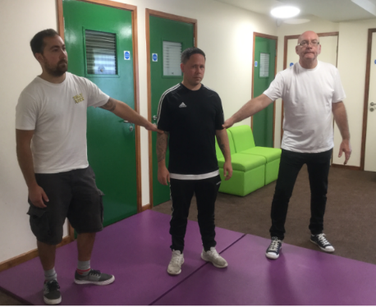

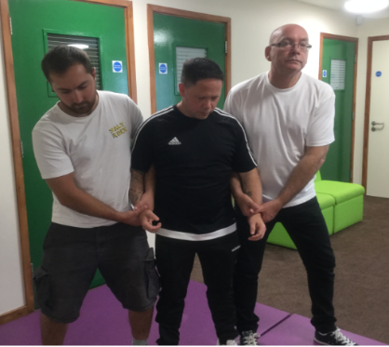

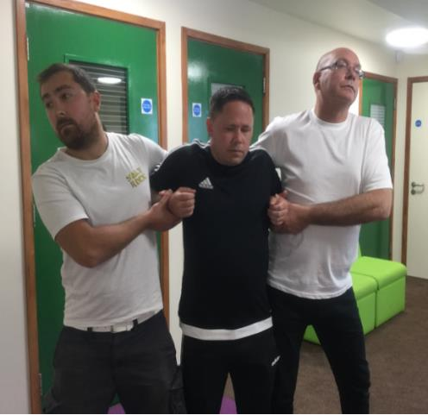

The rescue shape is not designed to be maintained but is used as a familiar shape to return to between transitions.

**Elbow tuck shape:**

Staff arms either side of the CYP’s arm

Both hands thumb on top

CYP’s shape

Staff shape

All elbow tucks can start from this rescue shape

**Elbow tuck rescue shape**

Often the greatest risk when considering RPI is engaging and disengaging.

Engaging and disengaging is based on managing and closing down the arms by closing in on the upper arm close to the elbow before attempting to hold. Only when close to static should staff attempt to find the rescue shape (if using) on the lower part of the arm.



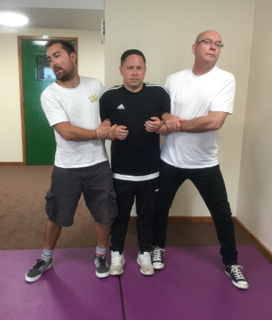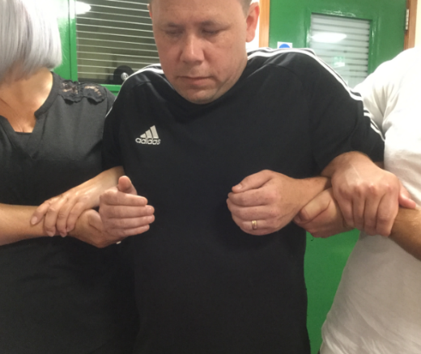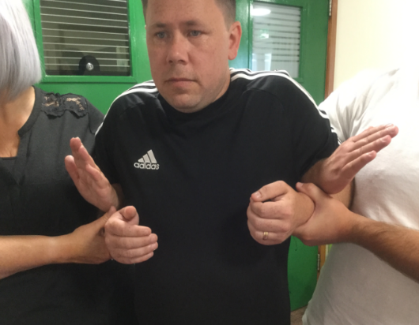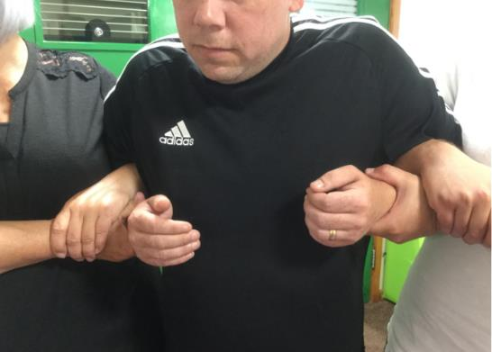

Head away.

Hips in.

Firm ‘A frame’ stance.

Use own body to help support tuck shape.

**Elbow tuck Figure of 4 standing**

Own hand holding own lower arm.

Cradling, or thumbs on top of CYP’s lower arm.

Maintain tuck.

Head away.

**Elbow tuck Figure of 4**

Transition from rescue shape to Figure of 4.

Ensure tuck is maintained keeping own thumbs on top or cradling the CYP’s arm.

‘Inside’ hand moves to hold own lower arm.

**Transition to elbow tuck Figure of 4**

The elbow tuck Figure of 4 is predominantly used to control arm movement in a range of operational situations.

**Elbow tuck Figure of four**

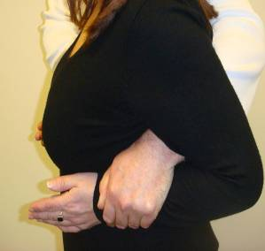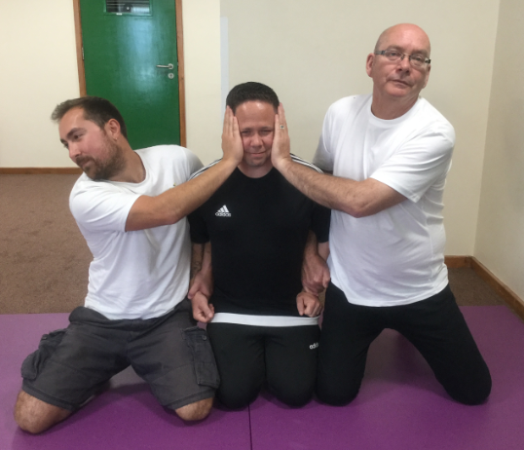

Lone worker elbow tuck should be used only where staff have a height and weight advantage.

**Elbow tuck:**

**lone worker**

To guard against spitting or head-butting, the staff can place their free hand on the side of the CYP’s face.

Make sure the hand is ‘cupped’ around glasses if they are worn and hands are not covering the ears.

**Elbow tuck Figure of 4 additional support**

CYPs who are allowed to plant their feet may choose to drop, kick or spit at staff. Keeping the feet occupied with movement occupies the brain and reduces the disruptive options.

If the CYP digs their feet in, resist the temptation to oppose the force, relax, step back and they will reduce their resistance.

**Elbow tuck Figure of 4**

**Lone worker elbow tuck**

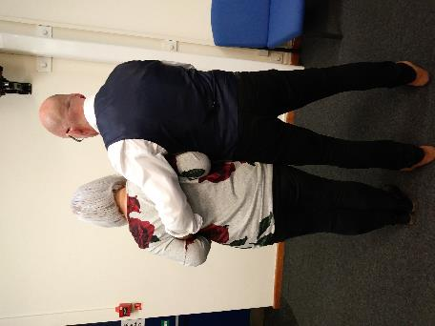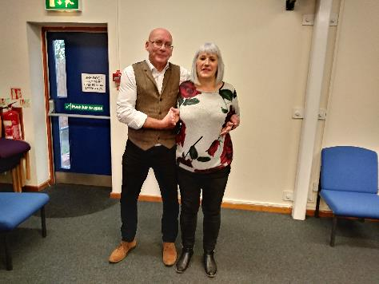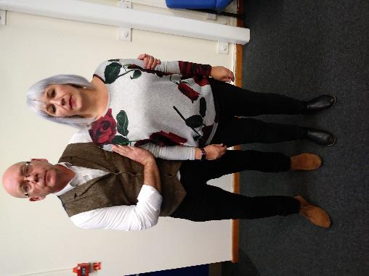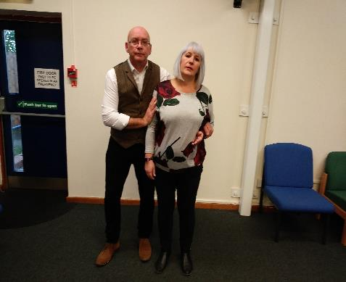

**Lone worker elbow tuck: staff shape, CYP shape**

The staff member’s arm goes behind the CYP’s back and holds the lower arm long bone with a closed mitten.

Hip in

Head away

Far hand, closed mitten drawing CYP’s elbow into their side not their stomach or chest

Near arm either protecting with an open mitten or elbow tuck position

Arm resting across the CYP’s shoulders

CYP’s shape

Staff shape

**Elbow tuck:**

**lone worker**

**Appendix 9 – Reflect, restore and repair**

CYP who are allowed to plant their feet may choose to drop, kick or spit at staff. Keeping the feet occupied with movement occupies the brain and reduces the disruptive options.

If the CYP digs their feet in, resist the temptation to oppose the force, relax, step back and the CYP will reduce resistance.

**Elbow tuck:**

**walking and turning**

Move assertively (prevents kicking / dropping)

Hips in (slightly behind if necessary)

Staff hands on the CYP’s shoulders

**Elbow tuck:**

**walking and turning**

CYP who are allowed to plant their feet may choose to drop, kick or spit at staff. Keeping the feet occupied with movement occupies the brain and reduces the disruptive options.

If the CYP digs their feet in, resist the temptation to oppose the force; relax, step back and the CYP will reduce resistance.

If the CYP drops to the floor, do not try to hold them up. As the circumstance allows, assist them to the floor and disengage the tuck as you do so.

**Lone worker elbow tuck: safer walking**

**Why this is important.**

**Doing this can support pupils to:​**

Feel heard and understood whilst avoiding criticism or blame.

Understand the impact of their behaviours whilst separating their behaviours from who they are as an individual.

Find ways to repair harm and restore relationships.

Learn new ways to regulate their emotions.

Develop empathy and understanding of others’ perspectives. ​

​

**Reflect, repair and restore:**

**barriers and adaptations**

Using visual resources may help CYP to process written or verbal information more effectively. ​

Puppets or books can also be used for an age and stage appropriate approach. Some CYP may feel too uncomfortable or threatened talking directly about their own behaviour so puppets provide a less intense way to do this.​

Timelines or flow charts can be helpful for pupils who may find it difficult to recall events. ​

We can provide longer processing time between questions​.

We can provide a further opportunity to reflect - give the CYP an ‘IOU’ card to pick up the conversation at another time

What can you do to help to put this right?

How can we make it OK for you to play/use the tools safely?

What could you do differently next time?

What do you think Archie might need?

.

What happened?

What were you thinking at the time?

How were you /Archie feeling?

How were the rest of the group feeling?

How can we make things better for Archie / you?

**Restorative questions**

Exploring what happened (tell the story).

Exploring what people were thinking and feeling at the time.

Exploring who has been affected and how.

Exploring how we can repair relationships.

Summarise what we have learnt so we are able to respond differently next time.

**More simply, a restorative approach involves**

*‘An approach to inappropriate behaviour which puts repairing harm done to relationships and people over and above the need for assigning blame and dispensing punishment.’*

Wright 1999

**A restorative approach**